Growth Models
Populations of people, animals, and items are growing all around us. By understanding how things grow, we can better understand what to expect in the future. In this chapter, we focus on time-dependant change.

Linear (Algebraic) Growth
Marco is a collector of antique soda bottles. His collection currently contains 437 bottles. Every year, he budgets enough money to buy 32 new bottles. Can we determine how many bottles he will have in 5 years, and how long it will take for his collection to reach 1000 bottles?

While both of these questions you could probably solve without an equation or formal mathematics, we are going to formalize our approach to this problem to provide a means to answer more complicated questions.

Suppose that P_{n} represents the number, or population, of bottles Marco has after n years. So P₀ would represent the number of bottles now, P₁ would represent the number of bottles after 1 year, P₂ would represent the number of bottles after 2 years, and so on. We could describe how Marco’s bottle collection is changing using:

P₀ = 437
P_{n} = P_{n-1} + 32

This is called a recursive relationship. A recursive relationship is a formula which relates the next value in a sequence to the previous values. Here, the number of bottles in year n can be found by adding 32 to the number of bottles in the previous year, P_{n-1}. Using this relationship, we could calculate:

P₁ = P₀ + 32 = 437 + 32 = 469
P₂ = P₁ + 32 = 469 + 32 = 501
P₃ = P₂ + 32 = 501 + 32 = 533
P₄ = P₃ + 32 = 533 + 32 = 565
P₅ = P₄ + 32 = 565 + 32 = 597

We have answered the question of how many bottles Marco will have in 5 years. However, solving how long it will take for his collection to reach 1000 bottles would require a lot more calculations.

While recursive relationships are excellent for describing simply and cleanly how a quantity is changing, they are not convenient for making predictions or solving problems that stretch far into the future. For that, a closed or explicit form for the relationship is preferred. An explicit equation allows us to calculate P_{n} directly, without needing to know P_{n-1}. While you may already be able to guess the explicit equation, let us derive it from the recursive formula. We can do so by selectively not simplifying as we go:

P₁ = 437 + 32 = 437 + 1(32)
P₂ = P₁ + 32 = 437 + 32 + 32 = 437 + 2(32)
P₃ = P₂ + 32 = (437 + 2(32)) + 32 = 437 + 3(32)
P₄ = P₃ + 32 = (437 + 3(32)) + 32 = 437 + 4(32)

You can probably see the pattern now, and generalize that
P_{n} = 437 + n(32) = 437 + 32n

Using this equation, we can calculate how many bottles he’ll have after 5 years:
P₅ = 437 + 32(5) = 437 + 160 = 597

We can now also solve for when the collection will reach 1000 bottles by substituting in 1000 for P_{n} and solving for n

1000 = 437 + 32n
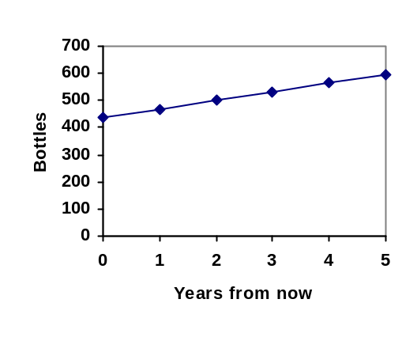563 = 32n
n = 563/32 = 17.59

So Marco will reach 1000 bottles in 18 years.

In the previous example, Marco’s collection grew by the same number of bottles every year. This constant change is the defining characteristic of linear growth. Plotting the values we calculated for Marco’s collection, we can see the values form a straight line, the shape of linear growth.

Linear Growth
If a quantity starts at size P₀ and grows by d every time period, then the quantity after n time periods can be determined using either of these relations:

Recursive form:
P_{n} = P_{n-1} + d

Explicit form:
P_{n} = P₀ + d n

In this equation, d represents the common difference – the amount that the population changes each time n increases by 1

Connection to prior learning – slope and intercept
You may recognize the common difference, d, in our linear equation as slope. In fact, the entire explicit equation should look familiar – it is the same linear equation you learned in algebra, probably stated as y = mx + b.
In the standard algebraic equation y = mx + b, b was the y-intercept, or the y value when x was zero. In the form of the equation we’re using, we are using P₀ to represent that initial amount.

In the y = mx + b equation, recall that m was the slope. You might remember this as “rise over run”, or the change in y divided by the change in x. Either way, it represents the same thing as the common difference, d, we are using – the amount the output P_{n} changes when the input n increases by 1.

The equations y = mx + b and P_{n} = P₀ + d n mean the same thing and can be used the same ways, we’re just writing it somewhat differently.

Example 1
The population of elk in a national forest was measured to be 12,000 in 2003, and was measured again to be 15,000 in 2007. If the population continues to grow linearly at this rate, what will the elk population be in 2014?

To begin, we need to define how we’re going to measure n. Remember that P₀ is the population when n = 0, so we probably don’t want to literally use the year 0. Since we already know the population in 2003, let us define n = 0 to be the year 2003. Then
P₀ = 12,000.

Next we need to find d. Remember d is the growth per time period, in this case growth per year. Between the two measurements, the population grew by 15,000-12,000 = 3,000, but it took 2007-2003 = 4 years to grow that much. To find the growth per year, we can divide: 3000 elk / 4 years = 750 elk in 1 year.

Alternatively, you can use the slope formula from algebra to determine the common difference, noting that the population is the output of the formula, and time is the input.

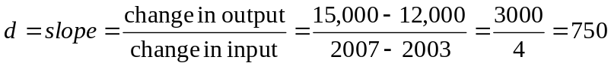

We can now write our equation in whichever form is preferred.

Recursive form:
P₀ = 12,000
P_{n} = P_{n-1} + 750

Explicit form:
P_{n} = 12,000 + 750n

To answer the question, we need to first note that the year 2014 will be n = 11, since 2014 is 11 years after 2003. The explicit form will be easier to use for this calculation:

P₁₁ = 12,000 + 750(11) = 20,250 elk
Example 2
Gasoline consumption in the US has been increasing steadily. Consumption data from 1992 to 2004 is shown below. Find a model for this data, and use it to predict consumption in 2016. If the trend continues, when will consumption reach 200 billion gallons?

Year | ‘92 | ‘93 | ‘94 | ‘95 | ‘96 | ‘97 | ‘98 | ‘99 | ‘00 | ‘01 | ‘02 | ‘03 | ‘04
Consumption (billion of gallons) | 110 | 111 | 113 | 116 | 118 | 119 | 123 | 125 | 126 | 128 | 131 | 133 | 136

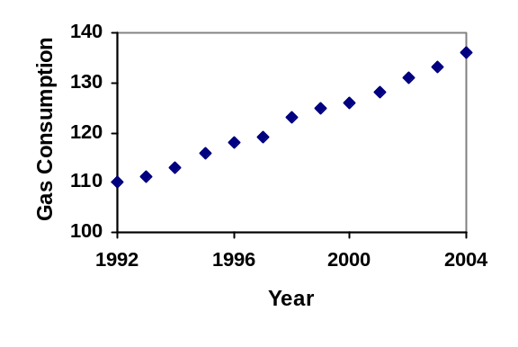
Plotting this data, it appears to have an approximately linear relationship:
While there are more advanced statistical techniques that can be used to find an equation to model the data, to get an idea of what is happening, we can find an equation by using two pieces of the data – perhaps the data from 1993 and 2003.

Letting n = 0 correspond with 1993 would give P₀ = 111 billion gallons.

To find d, we need to know how much the gas consumption increased each year, on average. From 1993 to 2003 the gas consumption increased from 111 billion gallons to 133 billion gallons, a total change of 133 – 111 = 22 billion gallons, over 10 years. This gives us an average change of 22 billion gallons / 10 year = 2.2 billion gallons per year.

Equivalently,

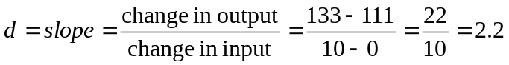billion gallons per year

We can now write our equation in whichever form is preferred.

Recursive form:
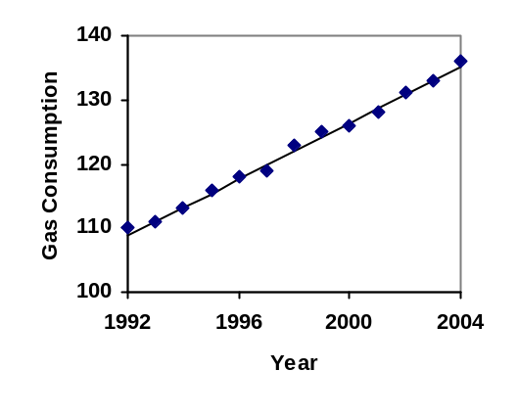P₀ = 111
P_{n} = P_{n-1} + 2.2

Explicit form:
P_{n} = 111 + 2.2n

Calculating values using the explicit form and plotting them with the original data shows how well our model fits the data.

We can now use our model to make predictions about the future, assuming that the previous trend continues unchanged. To predict the gasoline consumption in 2016:

n = 23 (2016 – 1993 = 23 years later)
P₂₃ = 111 + 2.2(23) = 161.6

Our model predicts that the US will consume 161.6 billion gallons of gasoline in 2016 if the current trend continues.

To find when the consumption will reach 200 billion gallons, we would set P_{n} = 200, and solve for n:
P_{n} = 200 Replace P_{n} with our model
111 + 2.2n = 200 Subtract 111 from both sides
2.2n = 89 Divide both sides by 2.2
n = 40.4545

This tells us that consumption will reach 200 billion about 40 years after 1993, which would be in the year 2033.

Example 3
The cost, in dollars, of a gym membership for n months can be described by the explicit equation P_{n} = 70 + 30n. What does this equation tell us?

The value for P₀ in this equation is 70, so the initial starting cost is $70. This tells us that there must be an initiation or start-up fee of $70 to join the gym.

The value for d in the equation is 30, so the cost increases by $30 each month. This tells us that the monthly membership fee for the gym is $30 a month.

Try it Now 1
The number of stay-at-home fathers in Canada has been growing steadily. While the trend is not perfectly linear, it is fairly linear. Use the data from 1976 and 2010 to find an explicit formula for the number of stay-at-home fathers, then use it to predict the number if 2020.

Year | 1976 | 1984 | 1991 | 2000 | 2010
Number of stay-at-home fathers | 20,610 | 28,725 | 43,530 | 47,665 | 53,555

When good models go bad
When using mathematical models to predict future behavior, it is important to keep in mind that very few trends will continue indefinitely.

Example 4
Suppose a four year old boy is currently 39 inches tall, and you are told to expect him to grow 2.5 inches a year.

We can set up a growth model, with n = 0 corresponding to 4 years old.

Recursive form:
P₀ = 39
P_{n} = P_{n-1} + 2.5

Explicit form:
P_{n} = 39 + 2.5n

So at 6 years old, we would expect him to be
P₂ = 39 + 2.5(2) = 44 inches tall

Any mathematical model will break down eventually. Certainly, we shouldn’t expect this boy to continue to grow at the same rate all his life. If he did, at age 50 he would be
P₄₆ = 39 + 2.5(46) = 154 inches tall = 12.8 feet tall!

When using any mathematical model, we have to consider which inputs are reasonable to use. Whenever we extrapolate, or make predictions into the future, we are assuming the model will continue to be valid.

Exponential (Geometric) Growth
Suppose that every year, only 10% of the fish in a lake have surviving offspring. If there were 100 fish in the lake last year, there would now be 110 fish. If there were 1000 fish in the lake last year, there would now be 1100 fish. Absent any inhibiting factors, populations of people and animals tend to grow by a percent of the existing population each year.

Suppose our lake began with 1000 fish, and 10% of the fish have surviving offspring each year. Since we start with 1000 fish, P₀ = 1000. How do we calculate P₁? The new population will be the old population, plus an additional 10%. Symbolically:

P₁ = P₀ + 0.10P₀

Notice this could be condensed to a shorter form by factoring:

P₁ = P₀ + 0.10P₀ = 1P₀ + 0.10P₀ = (1+ 0.10)P₀ = 1.10P₀

While 10% is the growth rate, 1.10 is the growth multiplier. Notice that 1.10 can be thought of as “the original 100% plus an additional 10%”

For our fish population,
P₁ = 1.10(1000) = 1100

We could then calculate the population in later years:
P₂ = 1.10P₁ = 1.10(1100) = 1210
P₃ = 1.10P₂ = 1.10(1210) = 1331

Notice that in the first year, the population grew by 100 fish, in the second year, the population grew by 110 fish, and in the third year the population grew by 121 fish.
While there is a constant percentage growth, the actual increase in number of fish is increasing each year.

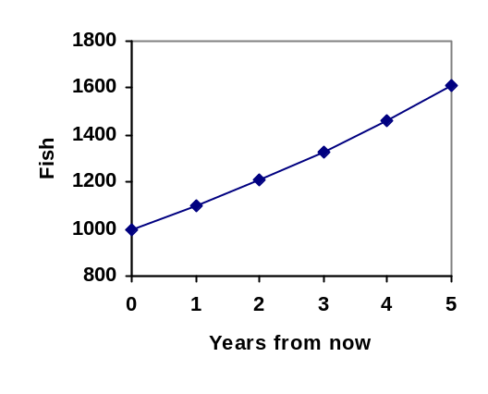Graphing these values we see that this growth doesn’t quite appear linear.

To get a better picture of how this percentage-based growth affects things, we need an explicit form, so we can quickly calculate values further out in the future.

Like we did for the linear model, we will start building from the recursive equation:

P₁ = 1.10P₀ = 1.10(1000)
P₂ = 1.10P₁ = 1.10(1.10(1000)) = 1.10²(1000)
P₃ = 1.10P₂ = 1.10(1.10²(1000)) = 1.10³(1000)
P₄ = 1.10P₃ = 1.10(1.10³(1000)) = 1.10⁴(1000)

Observing a pattern, we can generalize the explicit form to be:
P_{n} = 1.10^{n}(1000), or equivalently, P_{n} = 1000(1.10^{n})
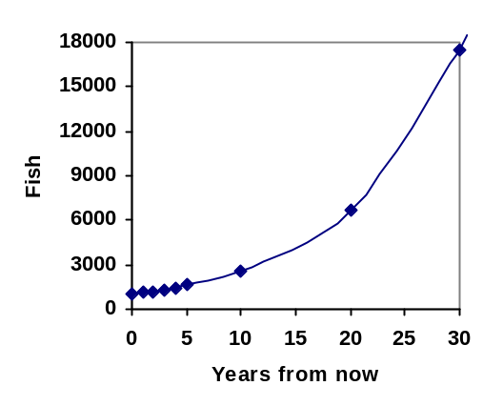
From this, we can quickly calculate the number of fish in 10, 20, or 30 years:

P₁₀ = 1.10¹⁰(1000) = 2594
P₂₀ = 1.10²⁰(1000) = 6727
P₃₀ = 1.10³⁰(1000) = 17449

Adding these values to our graph reveals a shape that is definitely not linear. If our fish population had been growing linearly, by 100 fish each year, the population would have only reached 4000 in 30 years compared to almost 18000 with this percent-based growth, called exponential growth.

In exponential growth, the population grows proportional to the size of the population, so as the population gets larger, the same percent growth will yield a larger numeric growth.

Exponential Growth
If a quantity starts at size P₀ and grows by R% (written as a decimal, r) every time period, then the quantity after n time periods can be determined using either of these relations:

Recursive form:
P_{n} = (1+r) P_{n-1}

Explicit form:
P_{n} = (1+r)^{n} P₀ or equivalently, P_{n} = P₀ (1+r)^{n}

We call r the growth rate.
The term (1+r) is called the growth multiplier, or common ratio.

Example 5
Between 2007 and 2008, Olympia, WA grew almost 3% to a population of 245 thousand people. If this growth rate was to continue, what would the population of Olympia be in 2014?

As we did before, we first need to define what year will correspond to n = 0. Since we know the population in 2008, it would make sense to have 2008 correspond to n = 0, so P₀ = 245,000. The year 2014 would then be n = 6.

We know the growth rate is 3%, giving r = 0.03.

Using the explicit form:
P₆ = (1+0.03)⁶ (245,000) = 1.19405(245,000) = 292,542.25

The model predicts that in 2014, Olympia would have a population of about 293 thousand people.

Evaluating exponents on the calculator
To evaluate expressions like (1.03)⁶, it will be easier to use a calculator than multiply 1.03 by itself six times. Most scientific calculators have a button for exponents. It is typically either labeled like:

^ , y^{x} , or x^{y} .

To evaluate 1.03⁶ we’d type 1.03 ^ 6, or 1.03 y^{x} 6. Try it out - you should get an answer around 1.1940523.

Try it Now 2
India is the second most populous country in the world, with a population in 2008 of about 1.14 billion people. The population is growing by about 1.34% each year. If this trend continues, what will India’s population grow to by 2020?

Example 6
A friend is using the equation P_{n} = 4600(1.072)^{n} to predict the annual tuition at a local college. She says the formula is based on years after 2010. What does this equation tell us?

In the equation, P₀ = 4600, which is the starting value of the tuition when n = 0. This tells us that the tuition in 2010 was $4,600.

The growth multiplier is 1.072, so the growth rate is 0.072, or 7.2%. This tells us that the tuition is expected to grow by 7.2% each year.

Putting this together, we could say that the tuition in 2010 was $4,600, and is expected to grow by 7.2% each year.

Example 7
In 1990, the residential energy use in the US was responsible for 962 million metric tons of carbon dioxide emissions. By the year 2000, that number had risen to 1182 million metric tons. If the emissions grow exponentially and continue at the same rate, what will the emissions grow to by 2050?

Similar to before, we will correspond n = 0 with 1990, as that is the year for the first piece of data we have. That will make P₀ = 962 (million metric tons of CO₂). In this problem, we are not given the growth rate, but instead are given that P₁₀ = 1182.

When n = 10, the explicit equation looks like:
P₁₀ = (1+r)¹⁰ P₀

We know the value for P₀, so we can put that into the equation:
P₁₀ = (1+r)¹⁰ 962

We also know that P₁₀ = 1182, so substituting that in, we get
1182 = (1+r)¹⁰ 962

We can now solve this equation for the growth rate, r. Start by dividing by 962.
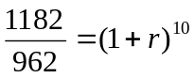 Take the 10th root of both sides
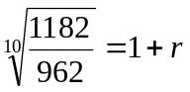 Subtract 1 from both sides
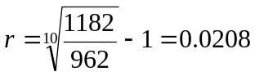 = 2.08%

So if the emissions are growing exponentially, they are growing by about 2.08% per year. We can now predict the emissions in 2050 by finding P₆₀

P₆₀ = (1+0.0208)⁶⁰ 962 = 3308.4 million metric tons of CO₂ in 2050

Rounding
As a note on rounding, notice that if we had rounded the growth rate to 2.1%, our calculation for the emissions in 2050 would have been 3347. Rounding to 2% would have changed our result to 3156. A very small difference in the growth rates gets magnified greatly in exponential growth. For this reason, it is recommended to round the growth rate as little as possible.

If you need to round, keep at least three significant digits - numbers after any leading zeros. So 0.4162 could be reasonably rounded to 0.416. A growth rate of 0.001027 could be reasonably rounded to 0.00103.

Evaluating roots on the calculator
In the previous example, we had to calculate the 10th root of a number. This is different than taking the basic square root, √. Many scientific calculators have a button for general roots. It is typically labeled like:
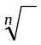 , 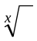 , or 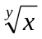

To evaluate the 3rd root of 8, for example, we’d either type 3 8, or 8 3, depending on the calculator. Try it on yours to see which to use – you should get an answer of 2.

If your calculator does not have a general root button, all is not lost. You can instead use the property of exponents which states that 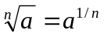. So, to compute the 3rd root of 8, you could use your calculator’s exponent key to evaluate 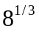. To do this, type:
8 y^{x} ( 1 ÷ 3 )

The parentheses tell the calculator to divide 1/3 before doing the exponent.

Try it Now 3
The number of users on a social networking site was 45 thousand in February when they officially went public, and grew to 60 thousand by October. If the site is growing exponentially, and growth continues at the same rate, how many users should they expect two years after they went public?

Example 8
Looking back at the last example, for the sake of comparison, what would the carbon emissions be in 2050 if emissions grow linearly at the same rate?

Again we will get n = 0 correspond with 1990, giving P₀ = 962. To find d, we could take the same approach as earlier, noting that the emissions increased by 220 million metric tons in 10 years, giving a common difference of 22 million metric tons each year.

Alternatively, we could use an approach similar to that which we used to find the exponential equation. When n = 10, the explicit linear equation looks like:
P₁₀ = P₀ + 10d

We know the value for P₀, so we can put that into the equation:
P₁₀ = 962 + 10d

Since we know that P₁₀ = 1182, substituting that in we get
1182 = 962 + 10d

We can now solve this equation for the common difference, d.
1182 – 962 = 10d
220 = 10d
d = 22
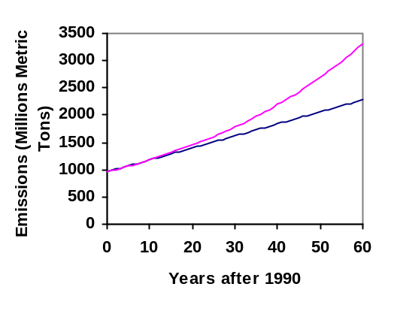This tells us that if the emissions are changing linearly, they are growing by 22 million metric tons each year. Predicting the emissions in 2050,

P₆₀ = 962 + 22(60) = 2282 million metric tons.

You will notice that this number is substantially smaller than the prediction from the exponential growth model. Calculating and plotting more values helps illustrate the differences.

So how do we know which growth model to use when working with data? There are two approaches which should be used together whenever possible:

- Find more than two pieces of data. Plot the values, and look for a trend. Does the data appear to be changing like a line, or do the values appear to be curving upwards?
- Consider the factors contributing to the data. Are they things you would expect to change linearly or exponentially? For example, in the case of carbon emissions, we could expect that, absent other factors, they would be tied closely to population values, which tend to change exponentially.

Solving Exponentials for Time: Logarithms
Earlier, we found that since Olympia, WA had a population of 245 thousand in 2008 and had been growing at 3% per year, the population could be modeled by the equation

P_{n} = (1+0.03)^{n} (245,000), or equivalently, P_{n} = 245,000(1.03)^{n}.

Using this equation, we were able to predict the population in the future.

Suppose we wanted to know when the population of Olympia would reach 400 thousand. Since we are looking for the year n when the population will be 400 thousand, we would need to solve the equation

400,000 = 245,000(1.03)^{n} dividing both sides by 245,000 gives
1.6327 = 1.03^{n}

One approach to this problem would be to create a table of values, or to use technology to draw a graph to estimate the solution.
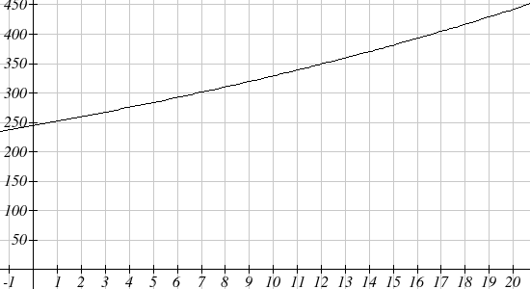

From the graph, we can estimate that the solution will be around 16 to 17 years after 2008 (2024 to 2025). This is pretty good, but we’d really like to have an algebraic tool to answer this question. To do that, we need to introduce a new function that will undo exponentials, similar to how a square root undoes a square. For exponentials, the function we need is called a logarithm. It is the inverse of the exponential, meaning it undoes the exponential. While there is a whole family of logarithms with different bases, we will focus on the common log, which is based on the exponential 10^{x}.

Common Logarithm
The common logarithm, written log(x), undoes the exponential 10^{x}
This means that log(10^{x}) = x, and likewise 10^{log(x)} = x
This also means the statement 10ª = b is equivalent to the statement log(b) = a

log(x) is read as “log of x”, and means “the logarithm of the value x”. It is important to note that this is not multiplication – the log doesn’t mean anything by itself, just like √ doesn’t mean anything by itself; it has to be applied to a number.
Example 9
Evaluate each of the following
a) log(100) b) log(1000) c) log(10000) d) log(1/100) e) log(1)

a) log(100) can be written as log(10²). Since the log undoes the exponential, log(10²) = 2
b) log(1000) = log(10³) = 3
c) log(10000) = log(10⁴) = 4
d) Recall that 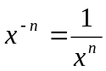. 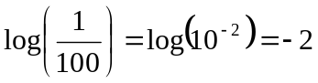
e) Recall that x⁰ = 1. log(1) = log(10⁰) = 0

It is helpful to note that from the first three parts of the previous example that the number we’re taking the log of has to get 10 times bigger for the log to increase in value by 1.
Of course, most numbers cannot be written as a nice simple power of 10. For those numbers, we can evaluate the log using a scientific calculator with a log button.

Example 10
Evaluate log(300)

Using a calculator, log(300) is approximately 2.477121

With an equation, just like we can add a number to both sides, multiply both sides by a number, or square both sides, we can also take the logarithm of both sides of the equation and end up with an equivalent equation. This will allow us to solve some simple equations.

Example 11
a) Solve 10^{x} = 1000 b) Solve 10^{x} = 3 c) Solve 2(10^{x}) = 8

a) Taking the log of both sides gives log(10^{x}) = log(1000)

Since the log undoes the exponential, log(10^{x}) = x. Similarly log(1000) = log(10³) = 3.
The equation simplifies then to x = 3.

b) Taking the log of both sides gives log(10^{x}) = log(3).

On the left side, log(10^{x}) = x, so x = log(3). We can approximate this value with a calculator. x ≈ 0.477

c) Here we would first want to isolate the exponential by dividing both sides of the equation by 2, giving
10^{x} = 4.

Now we can take the log of both sides, giving log(10^{x}) = log(4), which simplifies to
x = log(4) ≈ 0.602
This approach allows us to solve exponential equations with powers of 10, but what about problems like 2 = 1.03^{n} from earlier, which have a base of 1.03? For that, we need the exponent property for logs.

Properties of Logs: Exponent Property
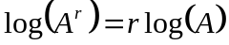

To show why this is true, we offer a proof.
Since the logarithm and exponential undo each other, 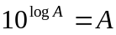.
So 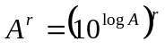
Utilizing the exponential rule that states 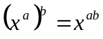,
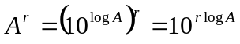

So then 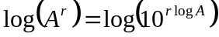
Again utilizing the property that the log undoes the exponential on the right side yields the result
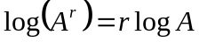

Example 12
Rewrite log(25) using the exponent property for logs

log(25) = log(5²) = 2log(5)

This property will finally allow us to answer our original question.

Solving exponential equations with logarithms
- Isolate the exponential. In other words, get it by itself on one side of the equation. This usually involves dividing by a number multiplying it.
- Take the log of both sides of the equation.
- Use the exponent property of logs to rewrite the exponential with the variable exponent multiplying the logarithm.
- Divide as needed to solve for the variable.

Example 13
If Olympia is growing according to the equation, P_{n} = 245(1.03)^{n}, where n is years after 2008, and the population is measured in thousands. Find when the population will be 400 thousand.

We need to solve the equation
400 = 245(1.03)^{n} Begin by dividing both sides by 245 to isolate the exponential
1.633 = 1.03^{n} Now take the log of both sides
log(1.633) = log(1.03^{n}) Use the exponent property of logs on the right side
log(1.633)= n log(1.03) Now we can divide by log(1.03)
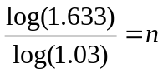 We can approximate this value on a calculator
n ≈ 16.591

Alternatively, after applying the exponent property of logs on the right side, we could have evaluated the logarithms to decimal approximations and completed our calculations using those approximations, as you’ll see in the next example. While the final answer may come out slightly differently, as long as we keep enough significant values during calculation, our answer will be close enough for most purposes.

Example 14
Polluted water is passed through a series of filters. Each filter removes 90% of the remaining impurities from the water. If you have 10 million particles of pollutant per gallon originally, how many filters would the water need to be passed through to reduce the pollutant to 500 particles per gallon?

In this problem, our “population” is the number of particles of pollutant per gallon. The initial pollutant is 10 million particles per gallon, so P₀ = 10,000,000. Instead of changing with time, the pollutant changes with the number of filters, so n will represent the number of filters the water passes through.

Also, since the amount of pollutant is decreasing with each filter instead of increasing, our “growth” rate will be negative, indicating that the population is decreasing instead of increasing, so r = -0.90.

We can then write the explicit equation for the pollutant:
P_{n} = 10,000,000(1 – 0.90)^{n} = 10,000,000(0.10)^{n}

To solve the question of how many filters are needed to lower the pollutant to 500 particles per gallon, we can set P_{n} equal to 500, and solve for n.

500 = 10,000,000(0.10)^{n} Divide both sides by 10,000,000
0.00005 = 0.10^{n} Take the log of both sides
log(0.00005) = log(0.10^{n}) Use the exponent property of logs on the right side
log(0.00005) = n log(0.10) Evaluate the logarithms to a decimal approximation
-4.301 = n (-1) Divide by -1, the value multiplying n
4.301 = n

It would take about 4.301 filters. Of course, since we probably can’t install 0.3 filters, we would need to use 5 filters to bring the pollutant below the desired level.

Try it Now 4
India had a population in 2008 of about 1.14 billion people. The population is growing by about 1.34% each year. If this trend continues, when will India’s population reach 1.2 billion?

Logistic Growth
In our basic exponential growth scenario, we had a recursive equation of the form
P_{n} = P_{n-1} + r P_{n-1}

In a confined environment, however, the growth rate may not remain constant. In a lake, for example, there is some maximum sustainable population of fish, also called a carrying capacity.

Carrying Capacity
The carrying capacity, or maximum sustainable population, is the largest population that an environment can support.

For our fish, the carrying capacity is the largest population that the resources in the lake can sustain. If the population in the lake is far below the carrying capacity, then we would expect the population to grow essentially exponentially. However, as the population approaches the carrying capacity, there will be a scarcity of food and space available, and the growth rate will decrease. If the population exceeds the carrying capacity, there won’t be enough resources to sustain all the fish and there will be a negative growth rate, causing the population to decrease back to the carrying capacity.

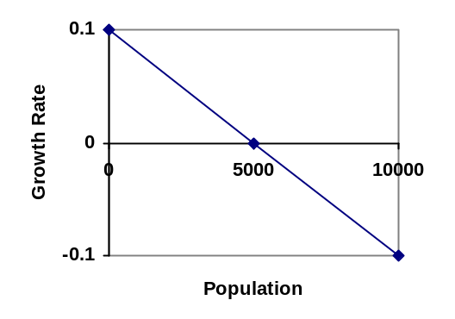If the carrying capacity was 5000, the growth rate might vary something like that in the graph shown. Note that this is a linear equation with intercept at 0.1 and slope 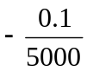, so we could write an equation for this adjusted growth rate as:

r_{adjusted} = 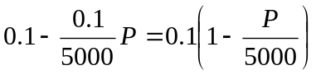

Substituting this in to our original exponential growth model for r gives
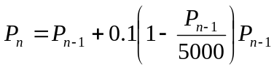

Logistic Growth
If a population is growing in a constrained environment with carrying capacity K, and absent constraint would grow exponentially with growth rate r, then the population behavior can be described by the logistic growth model:

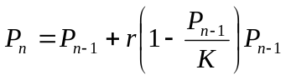

Unlike linear and exponential growth, logistic growth behaves differently if the populations grow steadily throughout the year or if they have one breeding time per year. The recursive formula provided above models generational growth, where there is one breeding time per year (or, at least a finite number); there is no explicit formula for this type of logistic growth.

Example 15
A forest is currently home to a population of 200 rabbits. The forest is estimated to be able to sustain a population of 2000 rabbits. Absent any restrictions, the rabbits would grow by 50% per year. Predict the future population using the logistic growth model.

Modeling this with a logistic growth model, r = 0.50, K = 2000, and P₀ = 200. Calculating the next year:

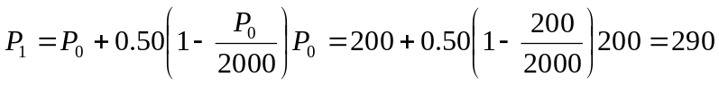

We can use this to calculate the following year:

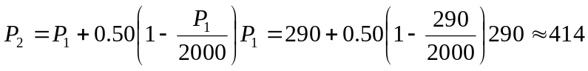
A calculator was used to compute several more values:

n | 0 | 1 | 2 | 3 | 4 | 5 | 6 | 7 | 8 | 9 | 10
P_{n} | 200 | 290 | 414 | 578 | 784 | 1022 | 1272 | 1503 | 1690 | 1821 | 1902

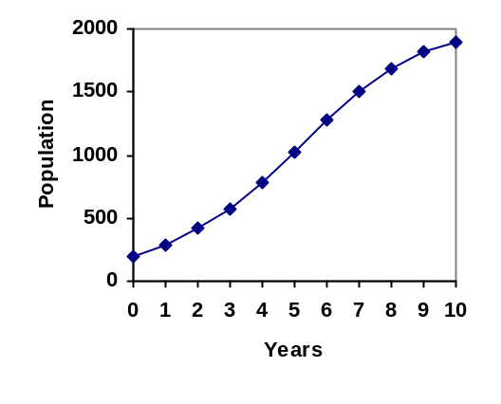
Plotting these values, we can see that the population starts to increase faster and the graph curves upwards during the first few years, like exponential growth, but then the growth slows down as the population approaches the carrying capacity.

Example 16
On an island that can support a population of 1000 lizards, there is currently a population of 600. These lizards have a lot of offspring and not a lot of natural predators, so have very high growth rate, around 150%. Calculating out the next couple generations:

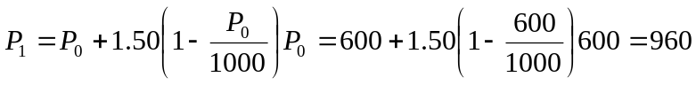
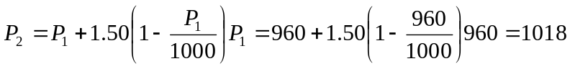

Interestingly, even though the factor that limits the growth rate slowed the growth a lot, the population still overshot the carrying capacity. We would expect the population to decline the next year.

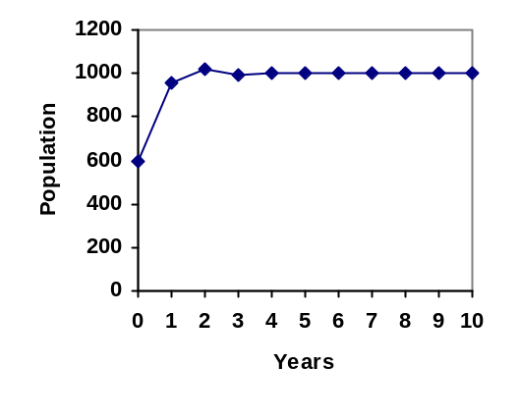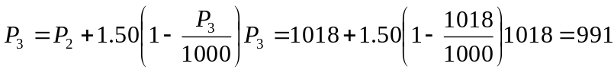

Calculating out a few more years and plotting the results, we see the population wavers above and below the carrying capacity, but eventually settles down, leaving a steady population near the carrying capacity.

Try it Now 5
A field currently contains 20 mint plants. Absent constraints, the number of plants would increase by 70% each year, but the field can only support a maximum population of 300 plants. Use the logistic model to predict the population in the next three years.

Example 17
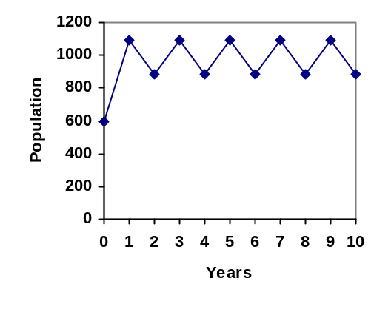On a neighboring island to the one from the previous example, there is another population of lizards, but the growth rate is even higher – about 205%.

Calculating out several generations and plotting the results, we get a surprise: the population seems to be oscillating between two values, a pattern called a 2-cycle.

While it would be tempting to treat this only as a strange side effect of mathematics, this has actually been observed in nature. Researchers from the University of California observed a stable 2-cycle in a lizard population in California.

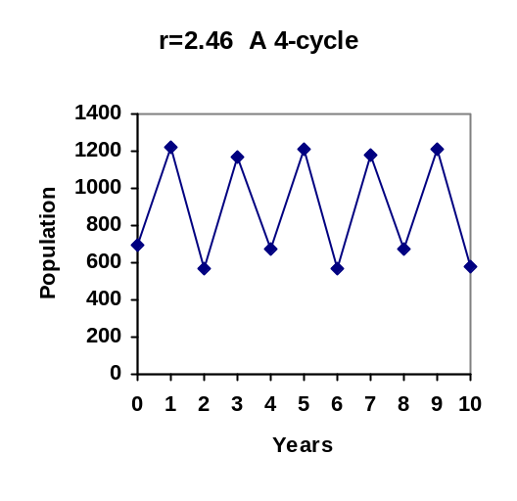Taking this even further, we get more and more extreme behaviors as the growth rate increases higher. It is possible to get stable 4-cycles, 8-cycles, and higher. Quickly, though, the behavior approaches chaos (remember the movie Jurassic Park?).

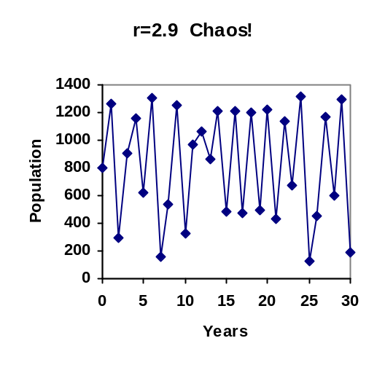

Try it Now Answers
1. Letting n = 0 correspond with 1976, then P₀ = 20,610.
From 1976 to 2010 the number of stay-at-home fathers increased by
53,555 – 20,610 = 32,945
This happened over 34 years, giving a common different d of 32,945 / 34 = 969.
P_{n} = 20,610 + 969n

Predicting for 2020, we use n = 44
P₄₄ = 20,610 + 969(44) = 63,246 stay-at-home fathers in 2020.

2. Using n = 0 corresponding with 2008,
P₁₂ = (1+0.0134)¹² (1.14) = about 1.337 billion people in 2020

3. Here we will measure n in months rather than years, with n = 0 corresponding to the February when they went public. This gives P₀ = 45 thousand. October is 8 months later, so P₈ = 60.

P₈ = (1+r)⁸ P₀
60 = (1+r)⁸ 45
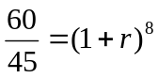
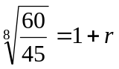
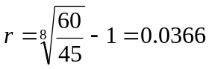, or 3.66%
The general explicit equation is P_{n} = (1.0366)^{n} 45
Predicting 24 months (2 years) after they went public:
P₂₄ = (1.0366)²⁴ 45 = 106.63 thousand users.

4. 1.14(1.0134)^{n} = 1.2. n = 3.853, which is during 2011
5. 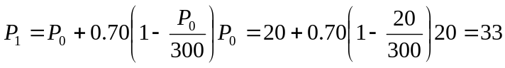
P₂ = 54
P₃ = 85

Exercises

Skills
- Marko currently has 20 tulips in his yard. Each year he plants 5 more.
  - Write a recursive formula for the number of tulips Marko has
  - Write an explicit formula for the number of tulips Marko has

- Pam is a Disc Jockey. Every week she buys 3 new albums to keep her collection current. She currently owns 450 albums.
  - Write a recursive formula for the number of albums Pam has
  - Write an explicit formula for the number of albums Pam has

- A store’s sales (in thousands of dollars) grow according to the recursive rule P_{n}=P_{n-1} + 15, with initial population P₀=40.
  - Calculate P₁ and P₂
  - Find an explicit formula for P_{n}
  - Use your formula to predict the store’s sales in 10 years
  - When will the store’s sales exceed $100,000?

- The number of houses in a town has been growing according to the recursive rule P_{n}=P_{n-1} + 30, with initial population P₀=200.
  - Calculate P₁ and P₂
  - Find an explicit formula for P_{n}
  - Use your formula to predict the number of houses in 10 years
  - When will the number of houses reach 400 houses?

- A population of beetles is growing according to a linear growth model. The initial population (week 0) was P₀=3, and the population after 8 weeks is P₈=67.
  - Find an explicit formula for the beetle population in week n
  - After how many weeks will the beetle population reach 187?

- The number of streetlights in a town is growing linearly. Four months ago (n = 0) there were 130 lights. Now (n = 4) there are 146 lights. If this trend continues,
  - Find an explicit formula for the number of lights in month n
  - How many months will it take to reach 200 lights?

- Tacoma's population in 2000 was about 200 thousand, and had been growing by about 9% each year.
  - Write a recursive formula for the population of Tacoma
  - Write an explicit formula for the population of Tacoma
  - If this trend continues, what will Tacoma's population be in 2016?
  - When does this model predict Tacoma’s population to exceed 400 thousand?

- Portland's population in 2007 was about 568 thousand, and had been growing by about 1.1% each year.
  - Write a recursive formula for the population of Portland
  - Write an explicit formula for the population of Portland
  - If this trend continues, what will Portland's population be in 2016?
  - If this trend continues, when will Portland’s population reach 700 thousand?

- Diseases tend to spread according to the exponential growth model. In the early days of AIDS, the growth rate was around 190%. In 1983, about 1700 people in the U.S. died of AIDS. If the trend had continued unchecked, how many people would have died from AIDS in 2005?

- The population of the world in 1987 was 5 billion and the annual growth rate was estimated at 2 percent per year. Assuming that the world population follows an exponential growth model, find the projected world population in 2015.

- A bacteria culture is started with 300 bacteria. After 4 hours, the population has grown to 500 bacteria. If the population grows exponentially,
  - Write a recursive formula for the number of bacteria
  - Write an explicit formula for the number of bacteria
  - If this trend continues, how many bacteria will there be in 1 day?
  - How long does it take for the culture to triple in size?

- A native wolf species has been reintroduced into a national forest. Originally 200 wolves were transplanted. After 3 years, the population had grown to 270 wolves. If the population grows exponentially,
  - Write a recursive formula for the number of wolves
  - Write an explicit formula for the number of wolves
  - If this trend continues, how many wolves will there be in 10 years?
  - If this trend continues, how long will it take the population to grow to 1000 wolves?

- One hundred trout are seeded into a lake. Absent constraint, their population will grow by 70% a year. The lake can sustain a maximum of 2000 trout. Using the logistic growth model,
  - Write a recursive formula for the number of trout
  - Calculate the number of trout after 1 year and after 2 years.

- Ten blackberry plants started growing in my yard. Absent constraint, blackberries will spread by 200% a month. My yard can only sustain about 50 plants. Using the logistic growth model,
  - Write a recursive formula for the number of blackberry plants in my yard
  - Calculate the number of plants after 1, 2, and 3 months

- In 1968, the U.S. minimum wage was $1.60 per hour. In 1976, the minimum wage was $2.30 per hour. Assume the minimum wage grows according to an exponential model where n represents the time in years after 1960.
  - Find an explicit formula for the minimum wage.
  - What does the model predict for the minimum wage in 1960?
  - If the minimum wage was $5.15 in 1996, is this above, below or equal to what the model predicts?

Concepts
- The population of a small town can be described by the equation P_{n} = 4000 + 70n, where n is the number of years after 2005. Explain in words what this equation tells us about how the population is changing.

- The population of a small town can be described by the equation P_{n} = 4000(1.04)^{n}, where n is the number of years after 2005. Explain in words what this equation tells us about how the population is changing.

Exploration
Most of the examples in the text examined growing quantities, but linear and exponential equations can also describe decreasing quantities, as the next few problems will explore.

- A new truck costs $32,000. The car’s value will depreciate over time, which means it will lose value. For tax purposes, depreciation is usually calculated linearly. If the truck is worth $24,500 after three years, write an explicit formula for the value of the car after n years.

- Inflation causes things to cost more, and for our money to buy less (hence your grandparents saying, "In my day, you could buy a cup of coffee for a nickel"). Suppose inflation decreases the value of money by 5% each year. In other words, if you have $1 this year, next year it will only buy you $0.95 worth of stuff. How much will $100 buy you in 20 years?

- Suppose that you have a bowl of 500 M&M candies, and each day you eat ¼ of the candies you have. Is the number of candies left changing linearly or exponentially? Write an equation to model the number of candies left after n days.

- A warm object in a cooler room will decrease in temperature exponentially, approaching the room temperature according to the formula 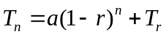 where T_{n} is the temperature after n minutes, r is the rate at which temperature is changing, a is a constant, and T_{r} is the temperature of the room. Forensic investigators can use this to predict the time of death of a homicide victim. Suppose that when a body was discovered (n = 0) it was 85 degrees. After 20 minutes, the temperature was measured again to be 80 degrees. The body was in a 70 degree room.
  - Use the given information with the formula provided to find a formula for the temperature of the body.
  - When did the victim die, if the body started at 98.6 degrees?

- Recursive equations can be very handy for modeling complicated situations for which explicit equations would be hard to interpret. As an example, consider a lake in which 2000 fish currently reside. The fish population grows by 10% each year, but every year 100 fish are harvested from the lake by people fishing.
  - Write a recursive equation for the number of fish in the lake after n years.
  - Calculate the population after 1 and 2 years. Does the population appear to be increasing or decreasing?
  - What is the maximum number of fish that could be harvested each year without causing the fish population to decrease in the long run?

- The number of Starbucks stores grew after first opened. The number of stores from 1990-2007, as reported on their corporate website, is shown below.
  - Carefully plot the data. Does is appear to be changing linearly or exponentially?
  - Try finding an equation to model the data by picking two points to work from. How well does the equation model the data?
  - Try using an equation of the form 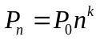, where k is a constant, to model the data. This type of model is called a Power model. Compare your results to the results from part b. Note: to use this model, you will need to have 1990 correspond with n = 1 rather than n = 0.

Year | Number of Starbucks stores |  | Year | Number of Starbucks stores
1990 | 84 |  | 1999 | 2498
1991 | 116 |  | 2000 | 3501
1992 | 165 |  | 2001 | 4709
1993 | 272 |  | 2002 | 5886
1994 | 425 |  | 2003 | 7225
1995 | 677 |  | 2004 | 8569
1996 | 1015 |  | 2005 | 10241
1997 | 1412 |  | 2006 | 12440
1998 | 1886 |  | 2007 | 15756

- Thomas Malthus was an economist who put forth the principle that population grows based on an exponential growth model, while food and resources grow based on a linear growth model. Based on this, Malthus predicted that eventually demand for food and resources would out outgrow supply, with doom-and-gloom consequences. Do some research about Malthus to answer these questions.
  - What societal changes did Malthus propose to avoid the doom-and-gloom outcome he was predicting?
  - Why do you think his predictions did not occur?
  - What are the similarities and differences between Malthus's theory and the logistic growth model?

http://www.bts.gov/publications/national_transportation_statistics/2005/html/table_04_10.html
http://www.fira.ca/article.php?id=140
http://www.eia.doe.gov/oiaf/1605/ggrpt/carbon.html
http://users.rcn.com/jkimball.ma.ultranet/BiologyPages/P/Populations2.html
http://www.starbucks.com/aboutus/Company_Timeline.pdf retrieved May 2009

